**Shareholder onboarding – Sequence diagram**

Scenario 1: A firm with existing shareholders

1. a: Issuer firm allows investors to be onboarded

A KoreConX firm (issuer) that wants to be part of ***Rialto’s*** ATS, it informs ***KoreConX*** about this decision.

* ***KoreConX*** responsibility to contact all of its shareholders, and suggest them to become part of Rialto’s ATS system.
* The shareholder will connect to KoreConX site and provide
  + Missing extra personal information (employer, salary, etc.)
  + Different ids like country specific ID, proof of residence, etc.
* The shareholder will submit the *subscription agreement*

See “*Solidus - Rialto - KCX integration v1.x.xlsx*”.

All the **KoreConX** shareholders will be informed that they can sign up in **Rialto ATS** system to trade their shares. They will click a link where they will go to *Rialto’s signup page*.

They will only be able to access this page through this link, as **Rialto** will NOT persist any personal information (besides first and last name maybe) until allowed to.

Once the investor clicks the link, it will be displayed an *Onboarding Authorization Page*. After clicking this page, *Investor Onboarding Acceptance* service (**Rialto**) will be called. **Rialto** will download ALL the user’s personal information available at KoreConX and pre populate ***physical investors table***:

Onboarding Authorization Page

/person/show/{id}

Solidus onboarding UIs

Then user will be redirected to the user onboarding UI which will be pre populated with its personal information available at ***KoreConX***. All the fields and documents that are not provided by **KoreConX** person service, will have to be manually uploaded/provided by the user.

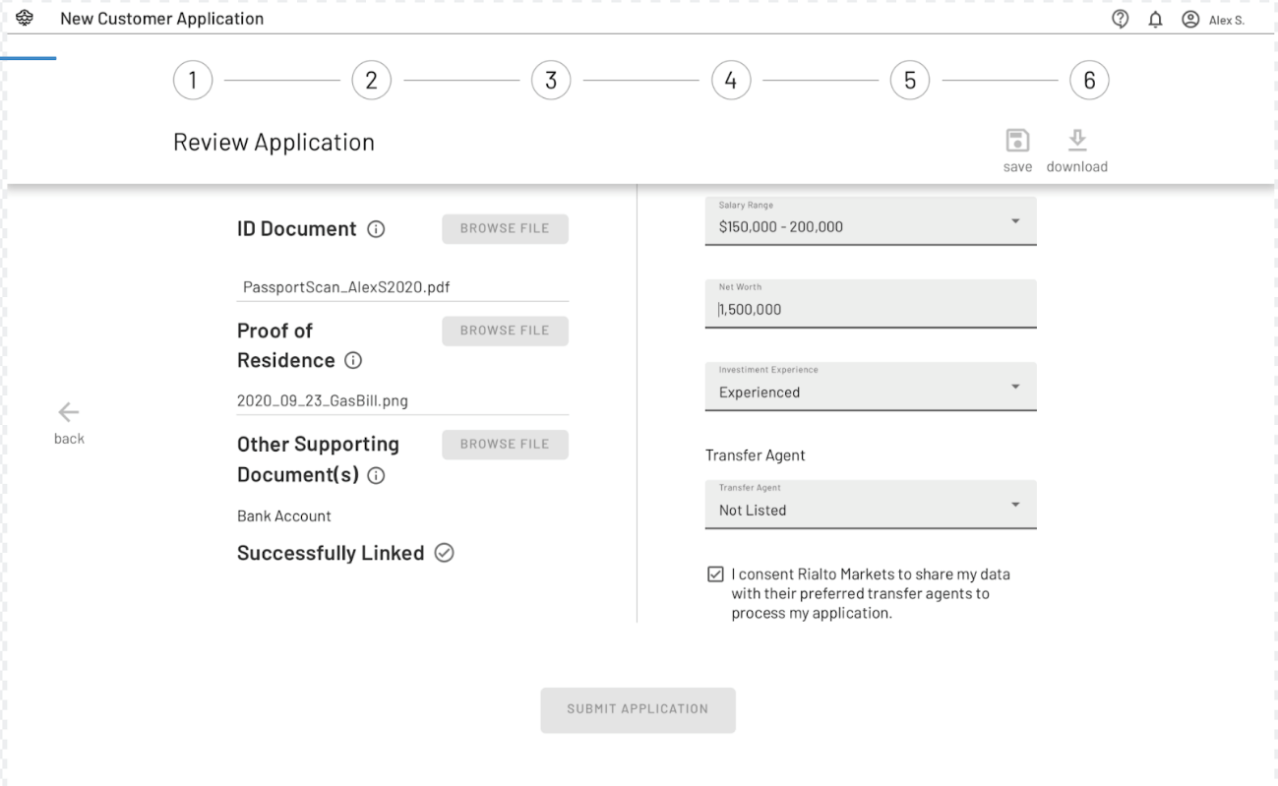

From this point on, the workflow/process will continue as it is described in ***Solidus*** document.

Scenario 3: An existing investor wants to update his personal information

**Questions to be analyzed**

* **Where will the user change its personal information? KCX**
* **Will he have to go to Rialto and also manually update this changed personal info?**
* **What fields will trigger the whole KYC process to be restarted?**